1. 
2. 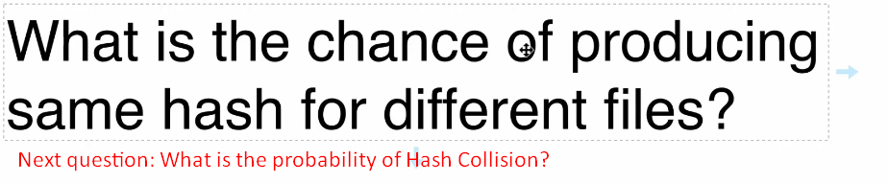
3. 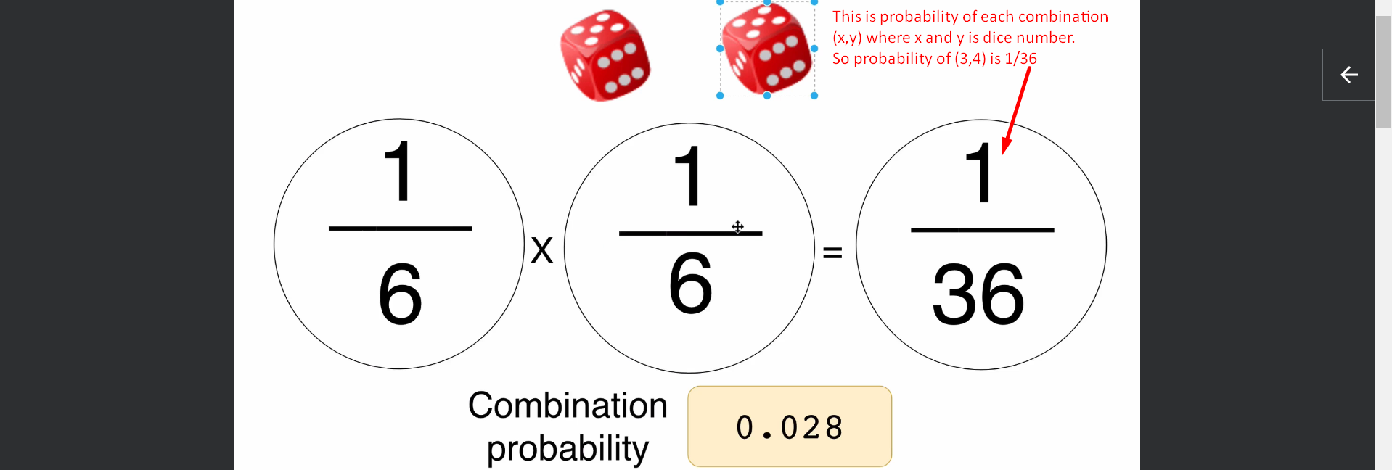
4. 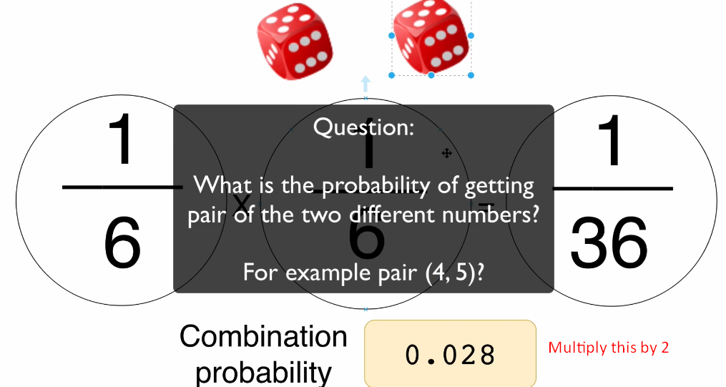
5. 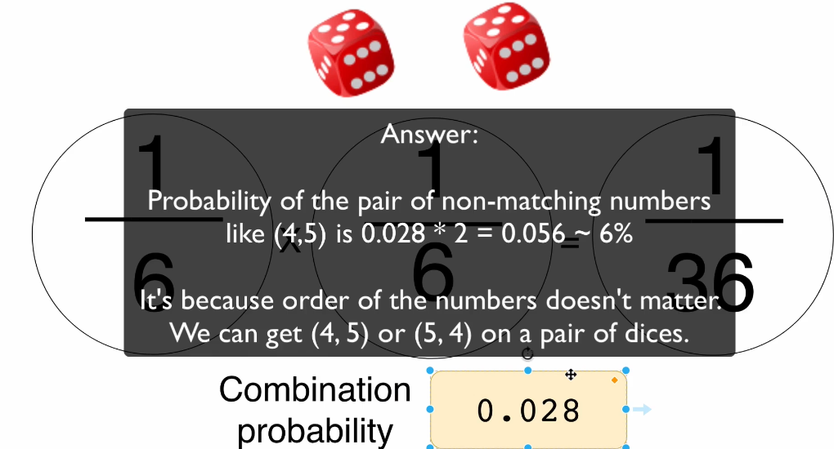
6. **Next lec**:   
   We studied the probability in Dice Game. Let’s apply this in SHA1 Combinations.